NAME : VARSHA KUMARI AGE: 22 Y/ F DATE: 15 April 2026
Refd. By.: DR. A K SINGH MBBS, UCMS, MS(G. SURGERY), FIAGES, FMAS, USMLE(USA), DNB(I), FICS, EISE, ECGMG(USA), MCh(NEUROSURGERY)
====================================================================

M.R.I. STUDY OF BRAIN
TECHNIQUE: Multiplanar, multisequence Magnetic Resonance Imaging of the brain was performed using a high-field 3.0 Tesla system.
FINDINGS:
BRAIN PARENCHYMA:
- Normal cortical and subcortical architecture.
- Tiny focal T2/FLAIR hyperintensity noted in the left frontal lobe.
- No associated mass effect, midline shift, or surrounding edema.
- No acute infarct, hemorrhage, or space-occupying lesion.
VENTRICULAR SYSTEM & CISTERNS:
- Ventricles normal in size and configuration.
- Basal cisterns patent.
WHITE MATTER:
- No diffuse white matter signal abnormality apart from the focal hyperintensity described above.
CORPUS CALLOSUM, BRAINSTEM & CEREBELLUM:
- Normal morphology and signal intensity.
EXTRA-AXIAL SPACES:
- No abnormal collection.
ORBITS, PARANASAL SINUSES & SKULL BASE:
- Orbits and paranasal sinuses unremarkable.
- Skull base structures intact.

IMPRESSION:
- Tiny focal T2/FLAIR hyperintensity in the left frontal lobe.
- No associated mass effect or edema.

DIFFERENTIAL DIAGNOSIS:
- Nonspecific gliotic focus (common incidental finding).
- Sequelae of migraine or chronic headache syndrome.
- Post-infective or post-inflammatory change.
- Prior minor traumatic insult.
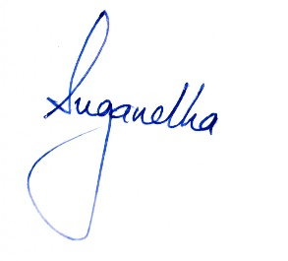
Please correlate with clinical findings.

